Setting up AWS cloud platform and Ubuntu VM

1. Go to <https://aws.amazon.com/>

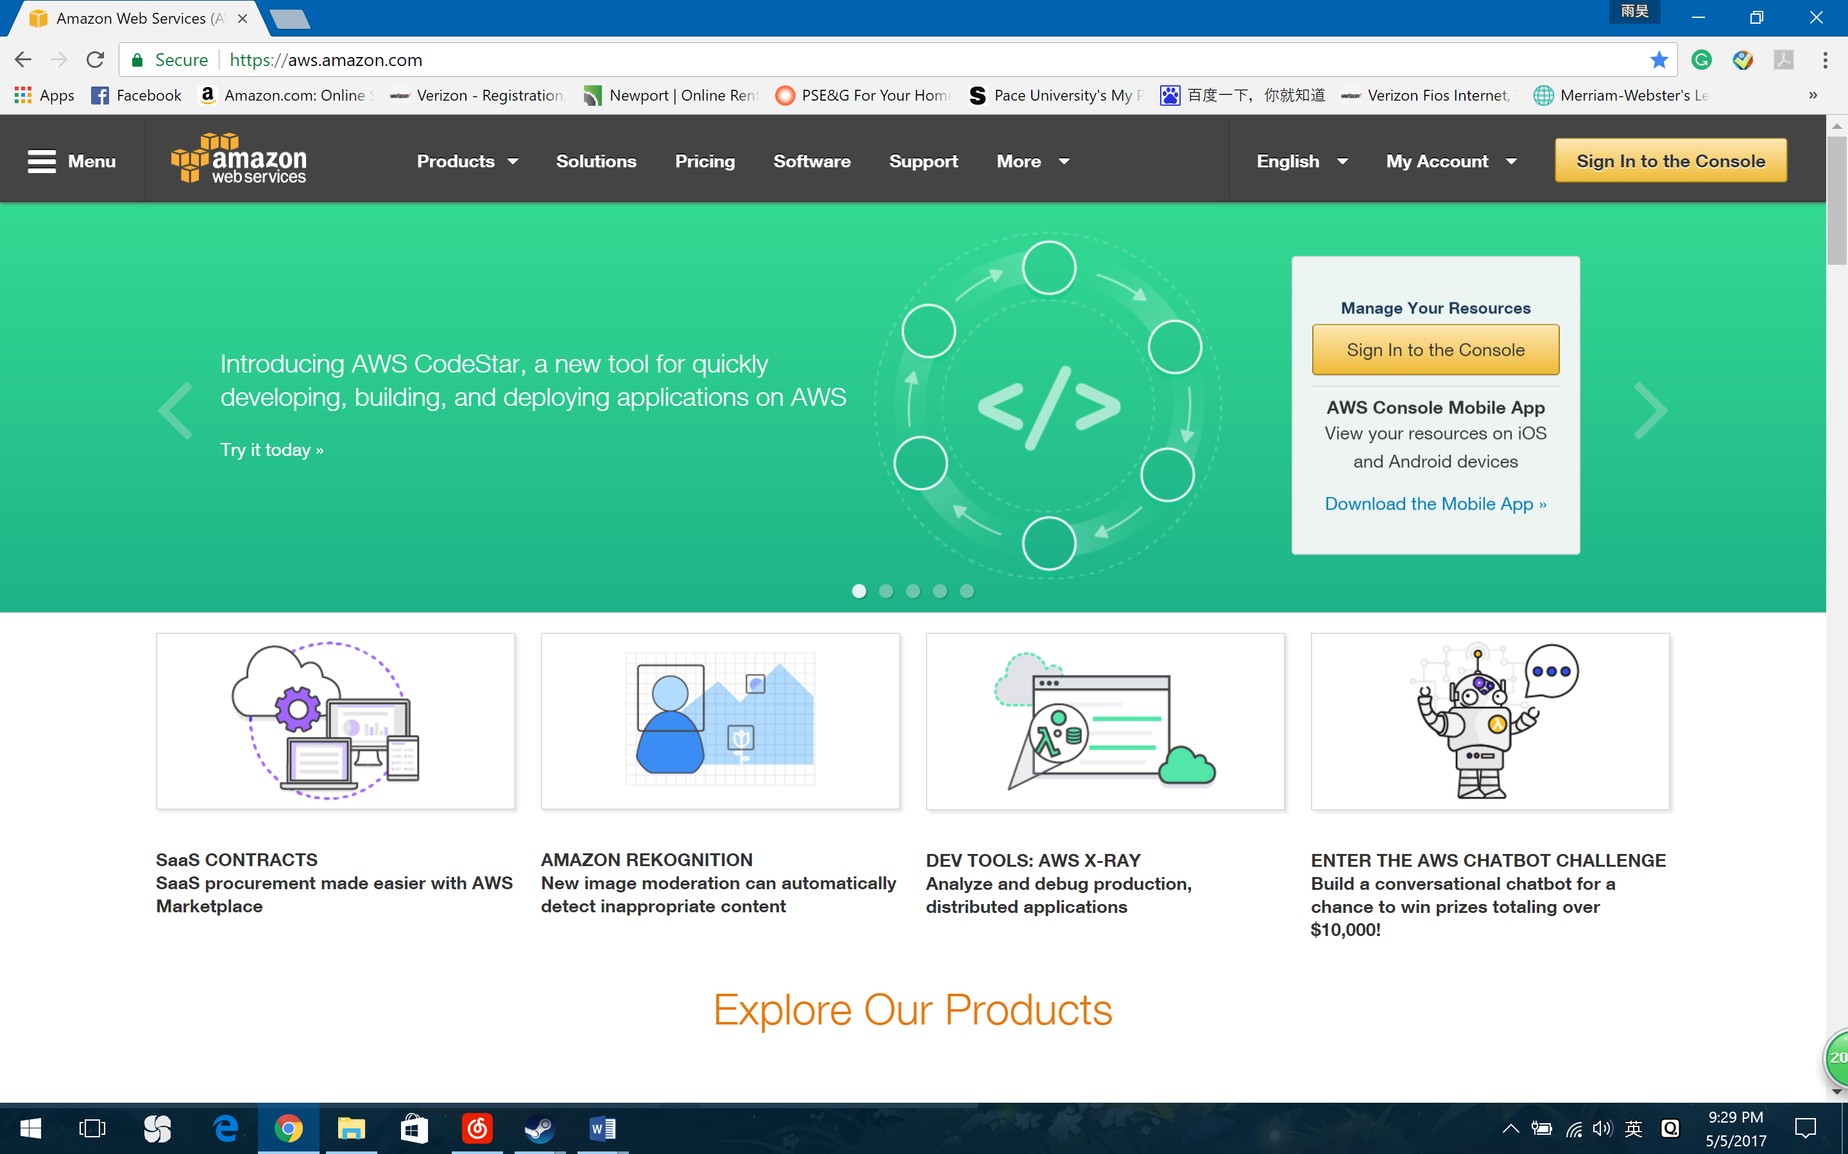

1. Click create free account (here is “Sign In the Console”)
2. Enter your e-mail or phone number. Choose “I am a new user.” Then click Log in

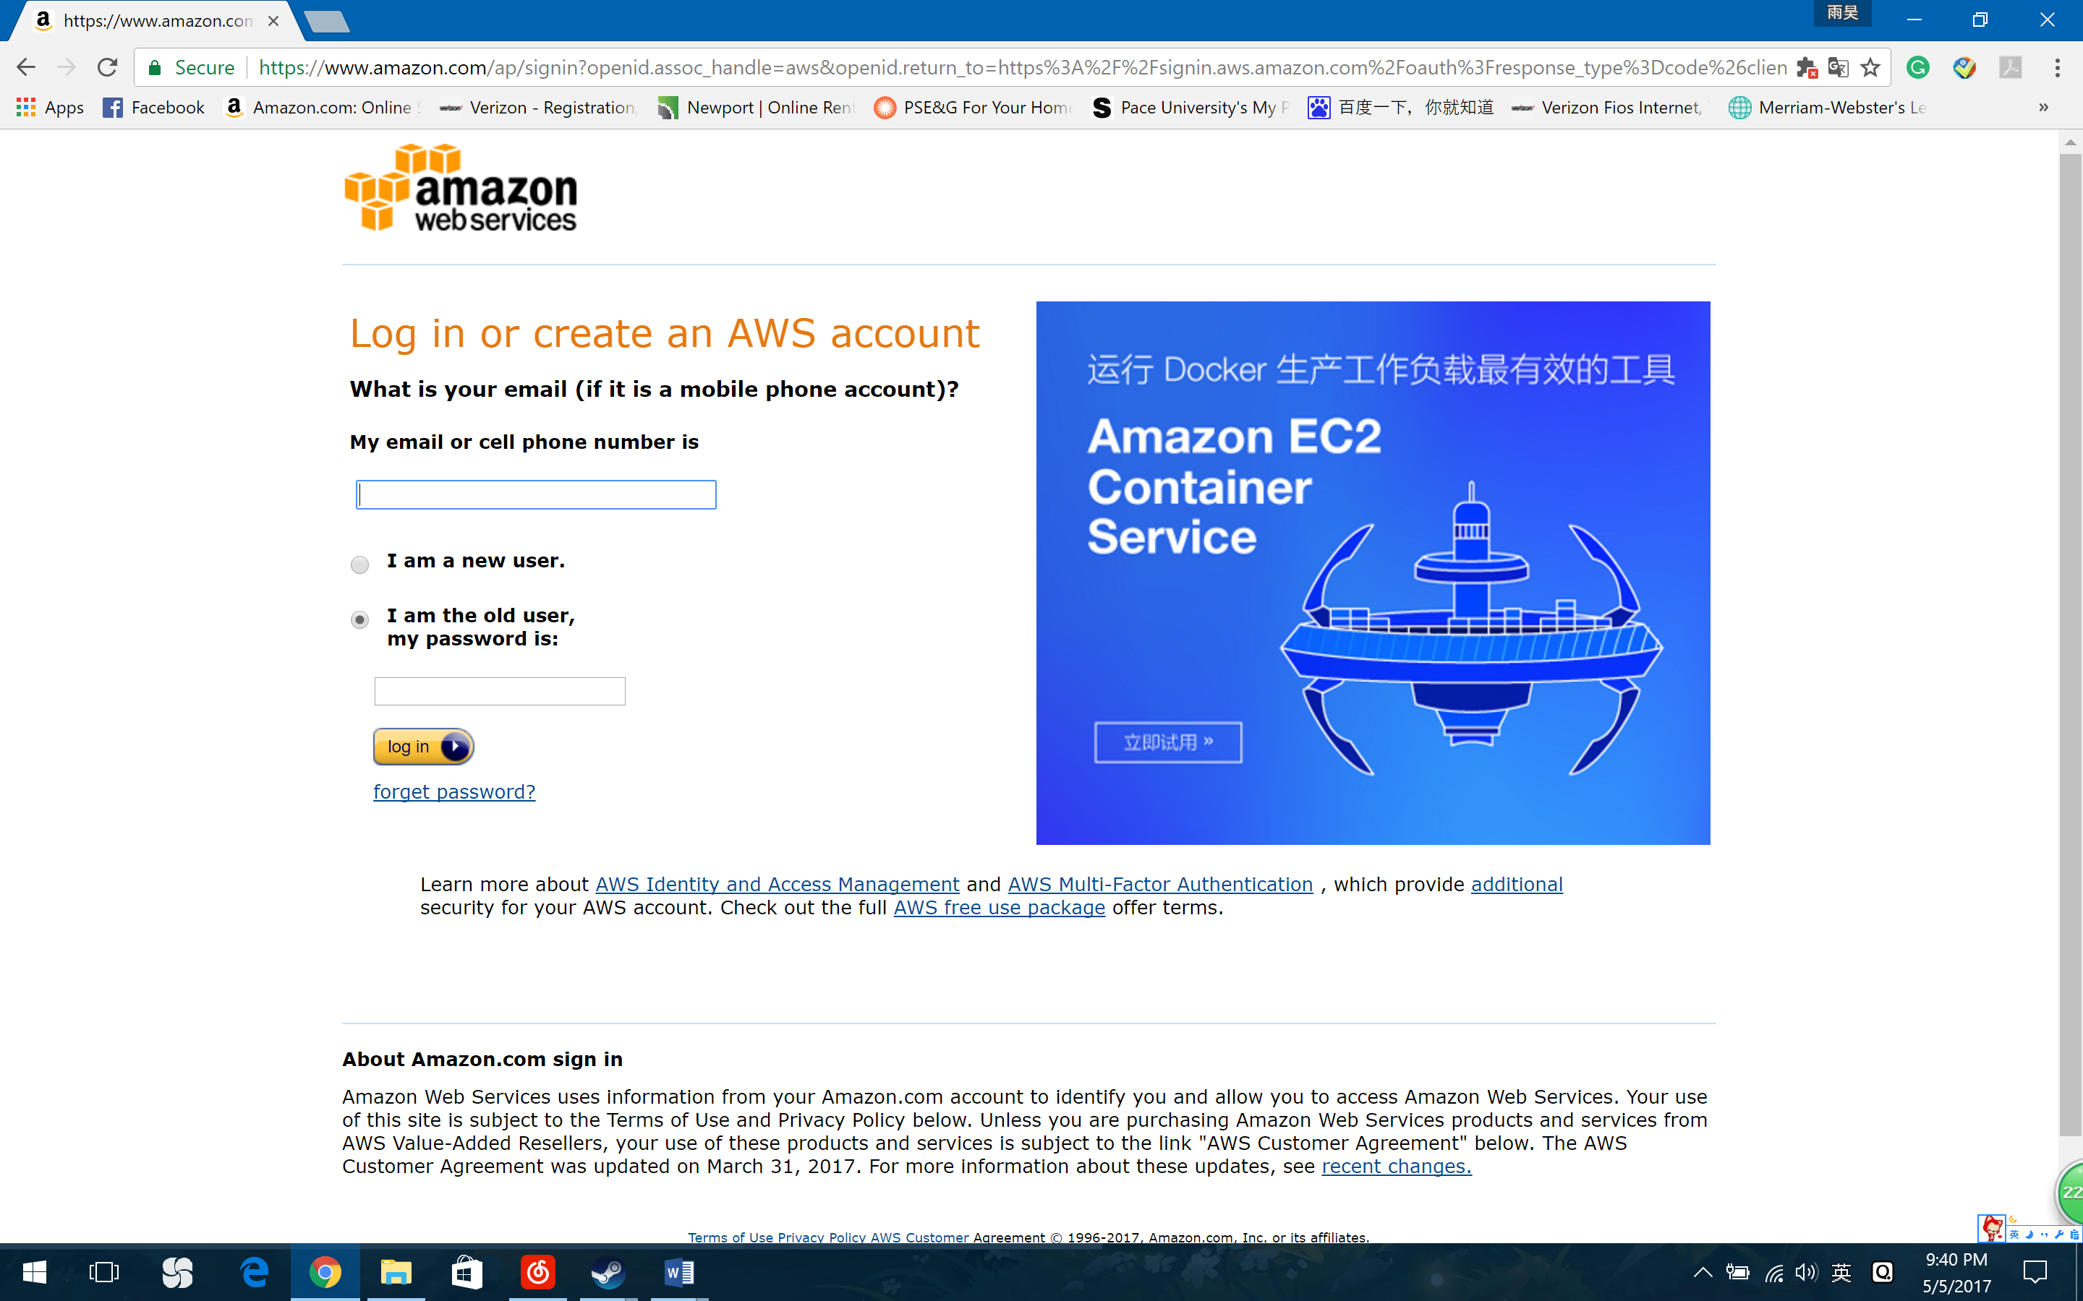

1. Type everything on the screen, and then click “create an account”

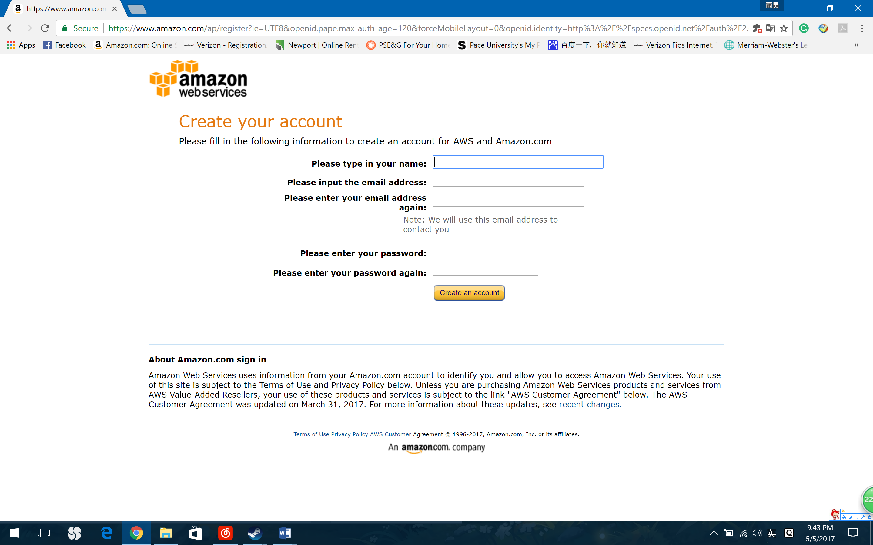

1. Select “Personal account”. Fill out all the details. Select “AWS Customer Agreement”. Click on button “Create Account and Continue”.

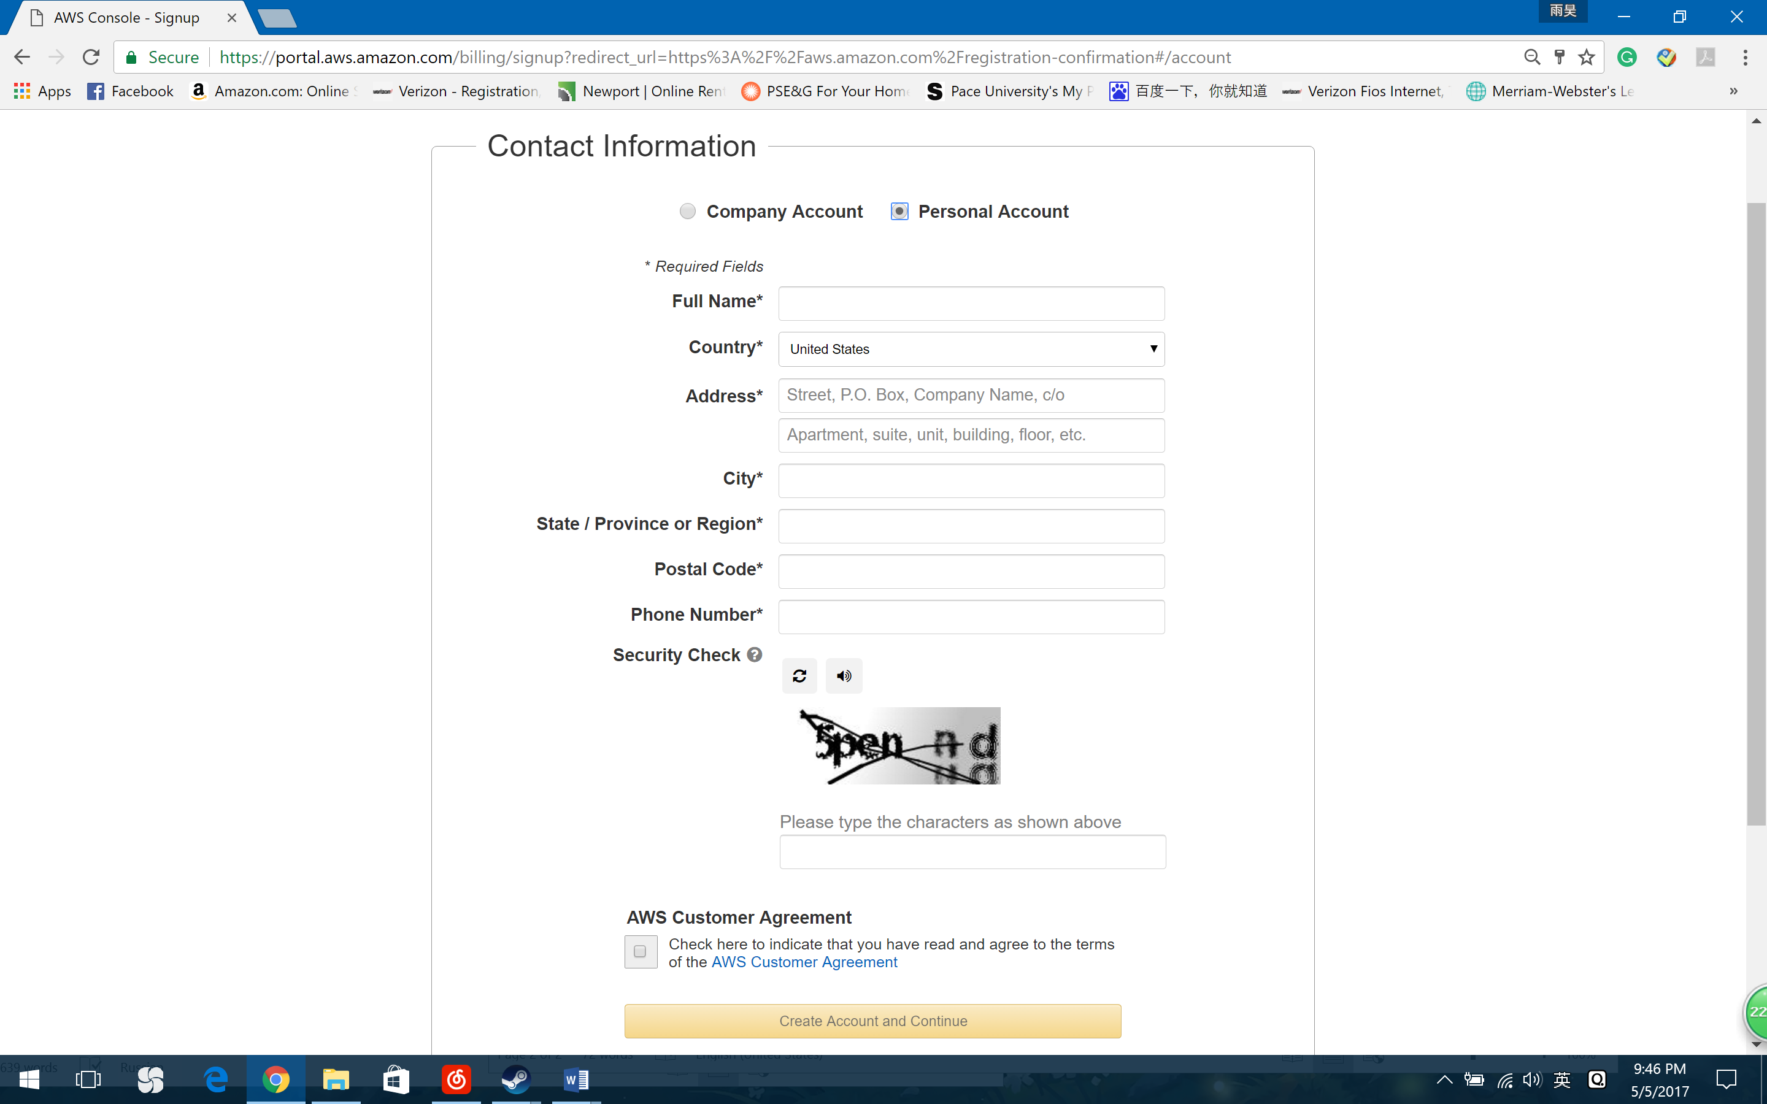

1. Fill out Payment Information.
2. Fill out identity verification. Click on call now.
3. You will receive a call from Amazon. Enter PIN on your phone during call.
4. Once Identity verification is complete, click on “Continue to Select your support Plan”.
5. Select Support Plan. I recommend Basic because of free. Click on Continue.
6. Then you will see confirmation page. Please Click on submit.
7. Log in to console.
8. Click on launch a virtual machine.

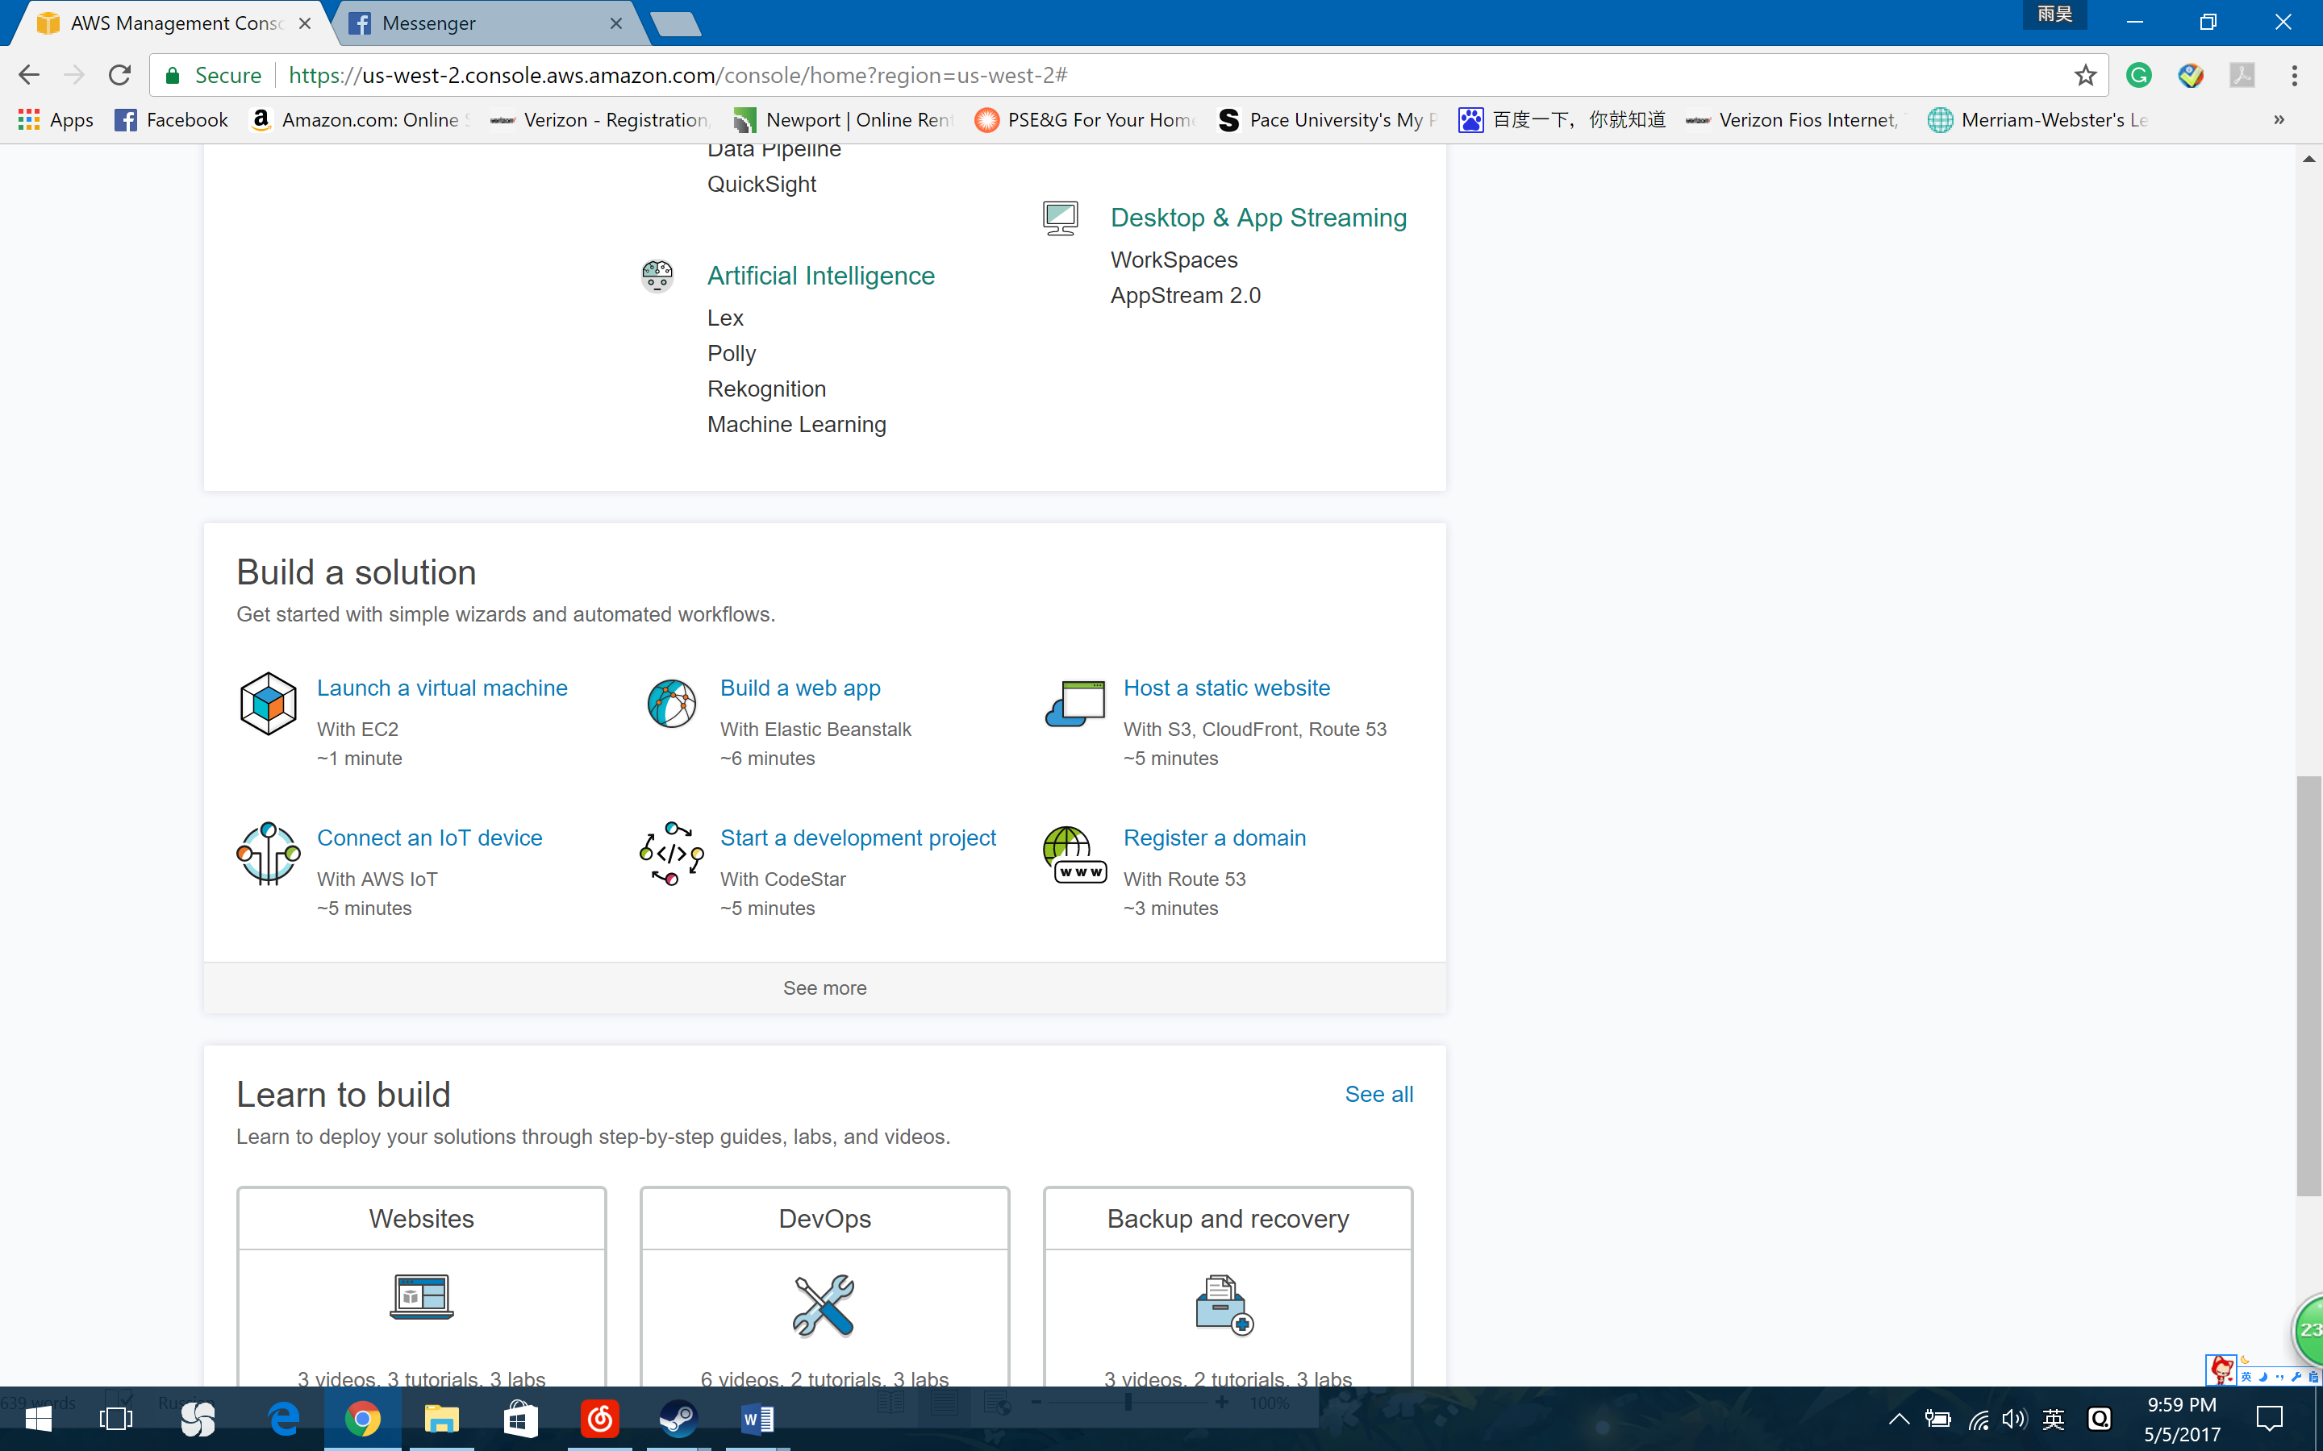

1. Click on get start
2. Name your Virtual machine. Example Instance1...etc. Your are free to name as per your convenient.
3. Choose your operating system. For example, I choose Ubuntu Server 14.04 LTS

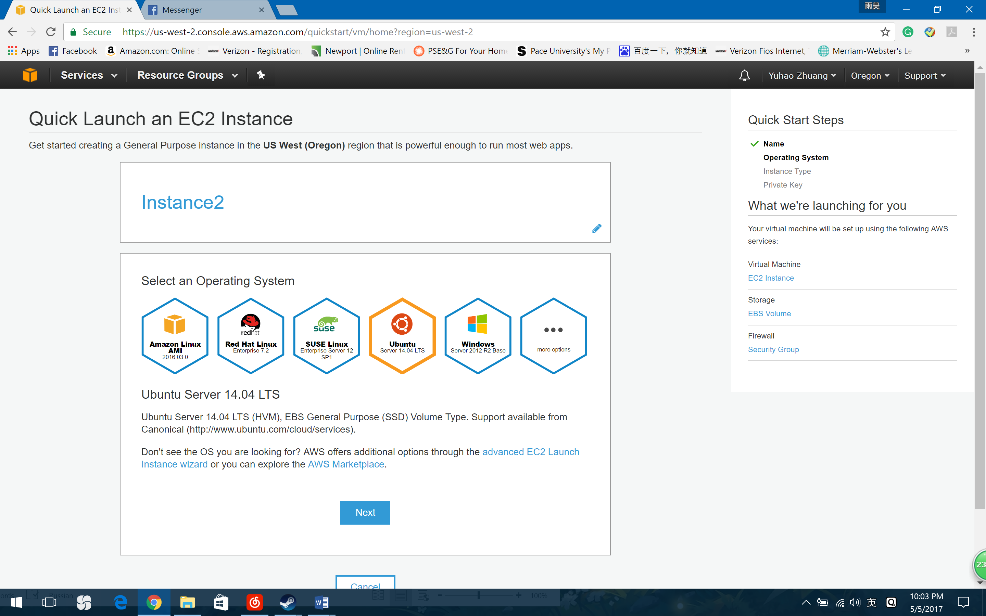

1. Click on Next.
2. Select an Instance type. I choose t2.micro.

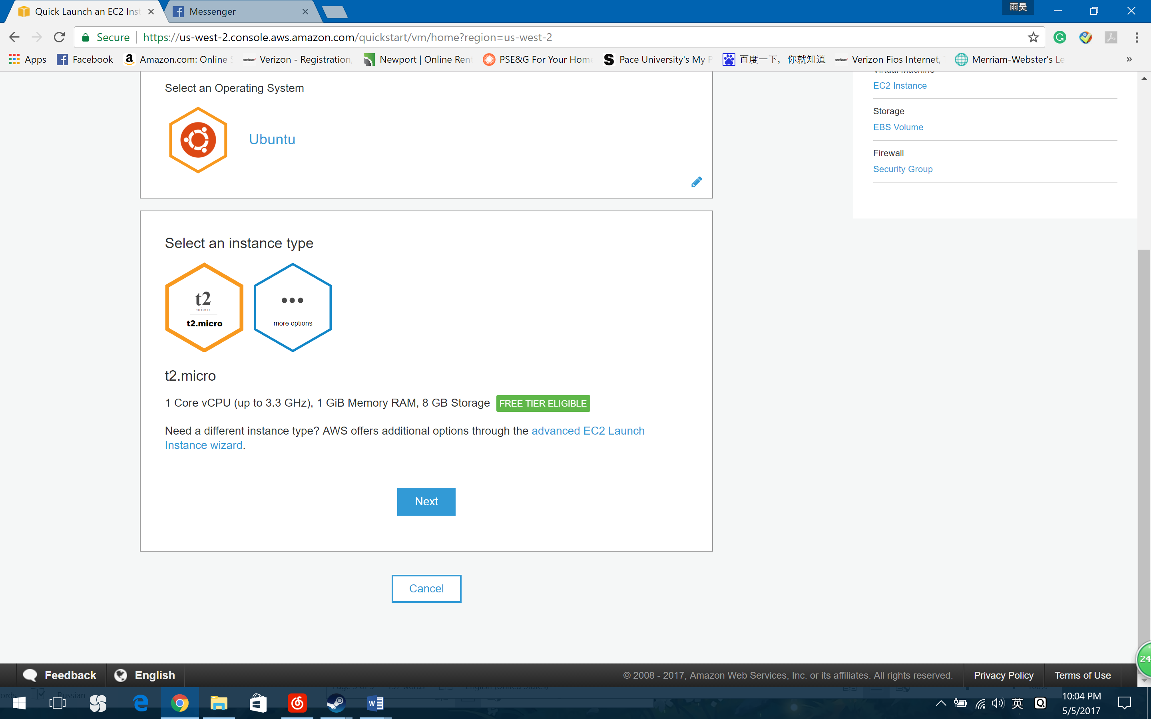

1. You will be asked to create a key pair. Give the name of your instance and click on download. **(Note: AWS does not keep a copy of your private key and it cannot be recovered if lost. Please save it in a safe place. Also, you can use it for another Instance.)**
2. Click on “Okay start Download”, then key will be downloaded now with extension.pem
3. Click on “Create this instance”. You will see a message”Your instance is launching”
4. Click on Proceed to EC2 instance
5. Click on Launch instance.

**With Putty to login in:**

1. Download putty.
2. Open PuttyGen. (Using search: PuTTYgen)
3. Select Type of key “SSH-2 RSA”

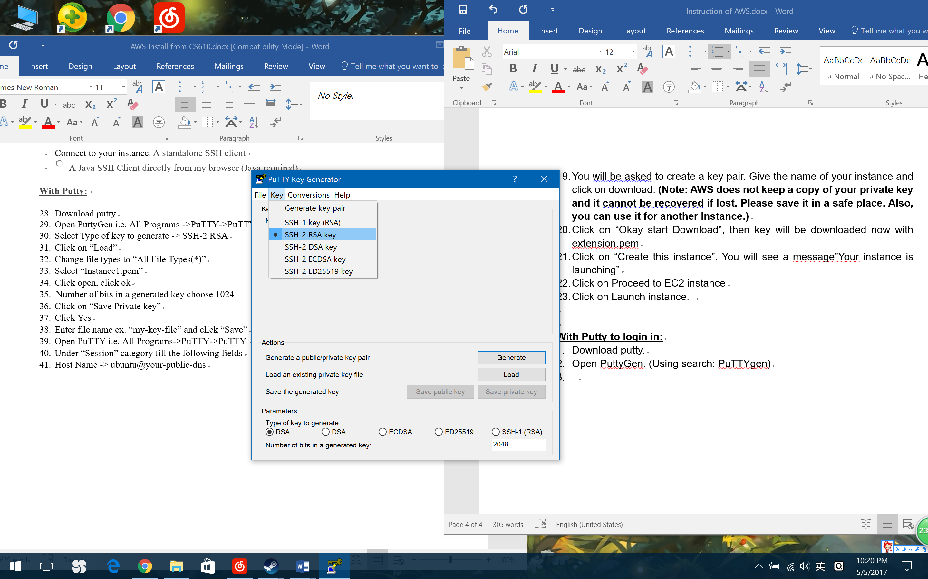

1. Click on “Load”
2. Change fiel tyoes to “All File Type(*)”
3. Select “Instance 1.pem”. Click open, click ok.
4. Number of bits in a generated key choose 1024
5. Click on “Save Private key”.
6. Click Yes.
7. Enter file name “KEY-AWS-Instance1” and click “Save”.
8. Open PuTTY. Also using windows search
9. Under “Session” category fill the following fields.
10. Host Name : ubuntu@your-public-dns

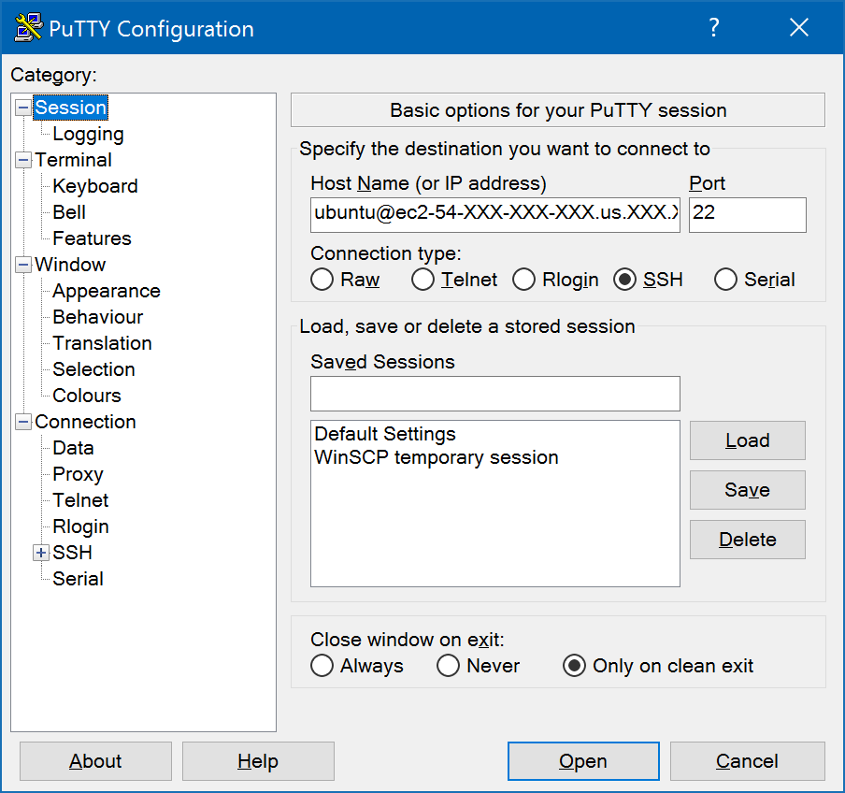

1. Under “Connection” category in left menu -> Expand “SSH” -> select “Auth”
2. Under “private key file for authentication” click “Browse”.
3. Locate and select your secret key file with “.ppk”. Example: “KEY-AWS-Instance1.ppk”

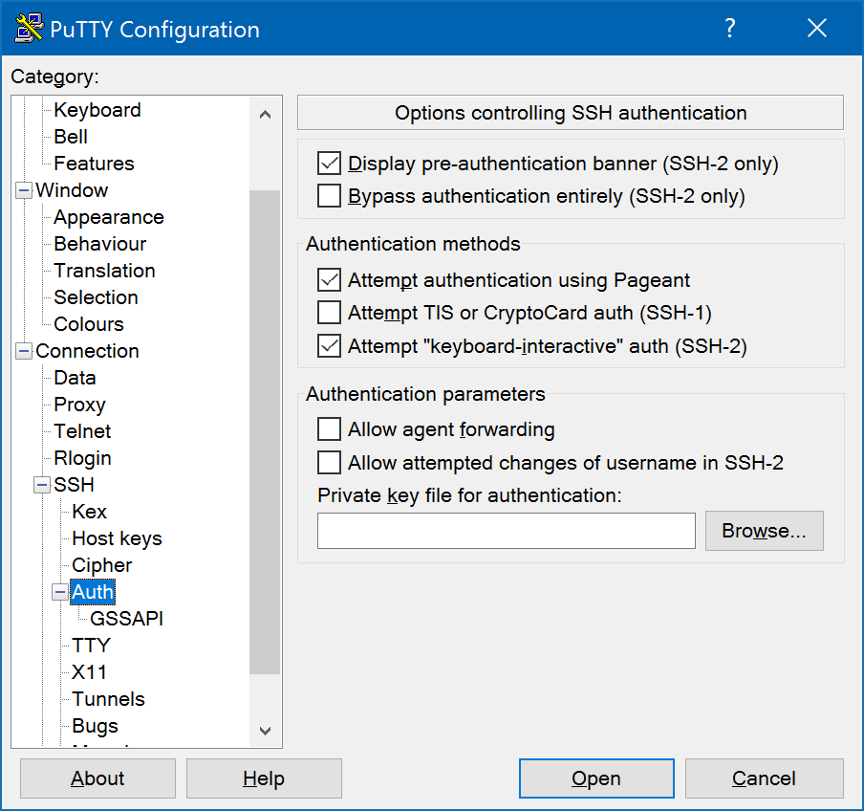

1. Click ”Open” under bottom right of main window.

**Connecting with WinSCP:**

1. Host name: Public DNS (example: ec2-54-XXX-XXX-XXX.compute-1.amazonaws.com)
2. Port number: 22
3. User name: Ubuntu
4. Password: blank.(Don’t type any thing)
5. Advanced=>SSH Authentication=>private key file**(the private key .pem must be converted into .ppk using PuttyGen)**
6. Click OK and Login.

Creating Security Group:

1. Go to Network Security => Security Groups.
2. Select the “Group id”
3. Go to “Inbound”
4. Edit “Inbound Rule” as below.

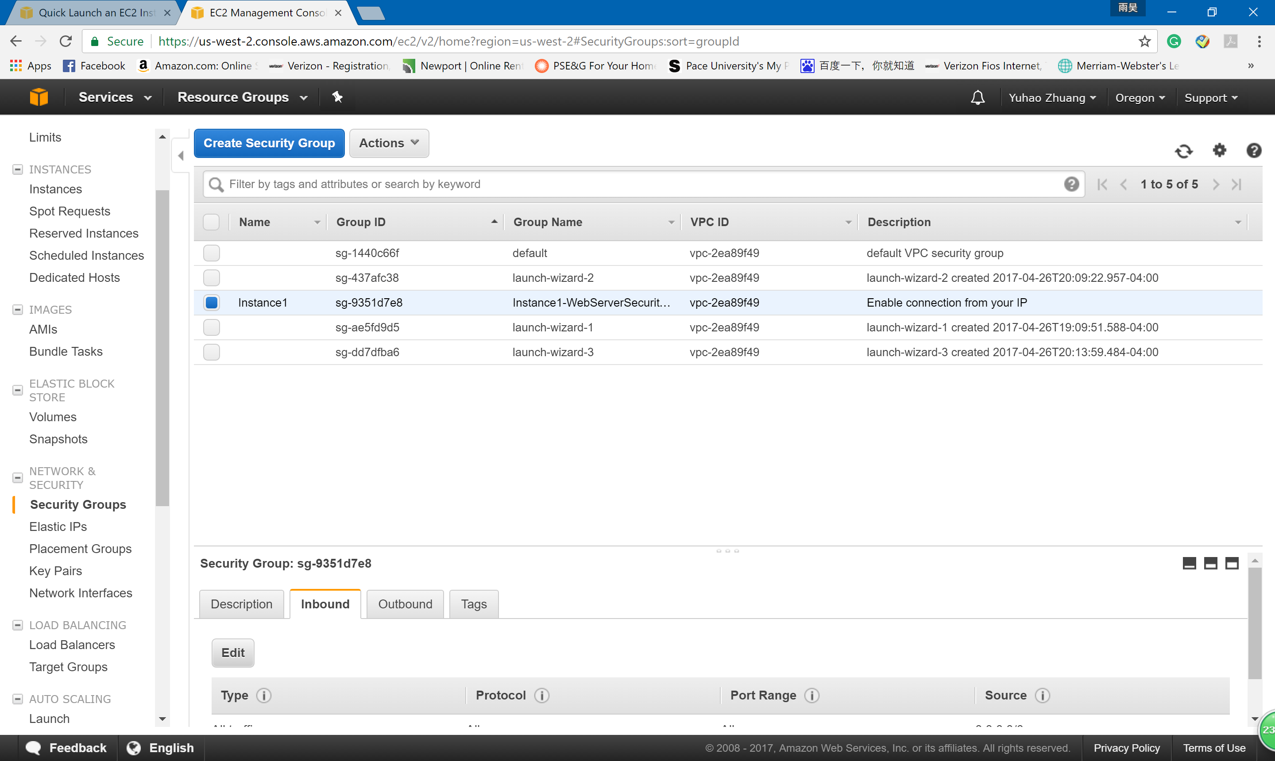

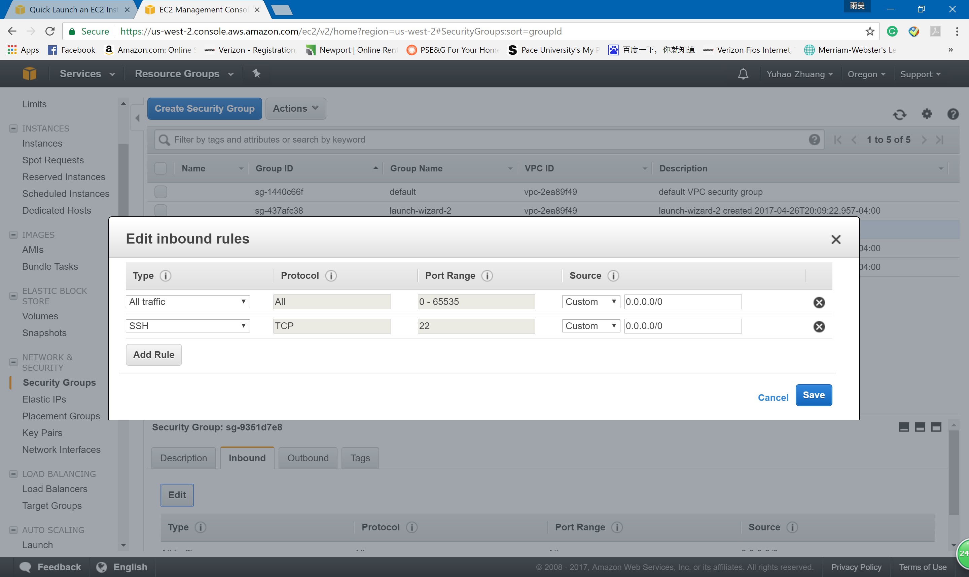

Tips:

1. If you do not use Instance any more. Please **terminate** it. You only have 750 hours per month. No matter the instance is stop or running, it will cost your total hours.
2. Remember check the bill usually. The storage is 5GB.